***Authors***:

Alexandru Gumaniuc

Jadyn Jacques

Ayodeji Olagoke

Rareș Matei Husărescu

Krystian Wiazowski

Ruike Yuan

Design document

Diyalo

MINA – IT2D

version 1.2

2023

Table of Contents

Version Management 3

Chapter 1: Introduction 4

Chapter 2: Description of the information system 5

Chapter 3: Data Flow Diagram 6

3.2 Sprint 3 6

3.2 Sprint 4 7

Chapter 4: Input 8

Chapter 5: Output 9

Chapter 6: Menu Structure and Authorization 10

Chapter 7: Resources 11

# Version Management

|  |  |
| --- | --- |
| **Version number** | **Changes** |
| 1.0 | Initial version of the document |
| 1.1 | Updated DFD, Chapter 4 and 5 |
| 1.2 | Updated Chapter 3 |

# Chapter 1: Introduction

This design document is meant to define the requirements to be implemented in software developed by group D for *Diyalo-NIC*. This will only include a module that will then be later connected to the whole robot created by *Diyalo-NIC*. Delivered package will provide coherent solution to hospitality in restaurants and hotels that will work together with other components already present in the interactive robot.

The aim of this software is to enable restaurants and hotels to facilitate their guests while sticking to the proper safety and security measures. The end goal of this functional design is to provide a formal document on all information pertaining to the application’s functions and what the developer’s intentions, capabilities and timeframes are, as well as its eventual management. This document also provides the reader with insight on a wide variety of technical components including data model, and input and output functions. Furthermore, it provides the reader with a look at the application’s structure in terms of options and user capabilities. Lastly, it will provide insight for any possible organizational consequences that can come with the product or service at hand.

The application will provide human tracking module to detect guests as human figures and follow them around the facility with the use of safe distance. Code will be developed in a simulated environment for the timeframe of the project and then uploaded to the physical robot for testing.

# Chapter 2: Description of the information system

The purpose of this information system is to paint a comprehensive picture for the *Diyalo-NIC* and their stakeholders that will make use of the software. This project will provide better work delegation and more efficient managing for the restaurants and hotels when it comes to guest service and guidance.

The system will make use of

* OpenCV libraries
* SSD and YOLO Tracking libraries
* Face_recognition libraries
* human models in various libraries
* movement publishers
* camera publishers
* gazebo 3D models

Incorporated features:

* Human Detection
* Human/Motion Tracking
* Face/Body recognition
* Movement
* Position/Movement tweaks

# Chapter 3: Data Flow Diagram

This chapter consists of Data Flow Diagrams for Sprint 3 and 4. Those outline the changes made across the sprints and include an overview of the module being built by the group.

Data Flow Diagram itself is a graphical representation of data movement within the system and its components, such as processes, data stores and external entities.

## 3.2 Sprint 3

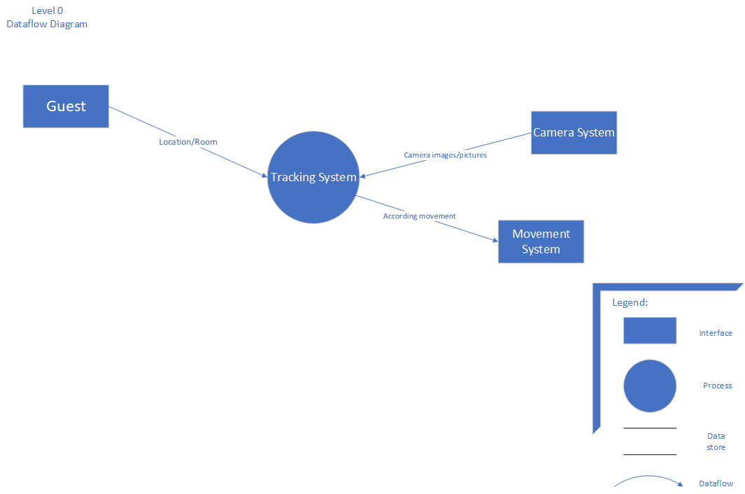

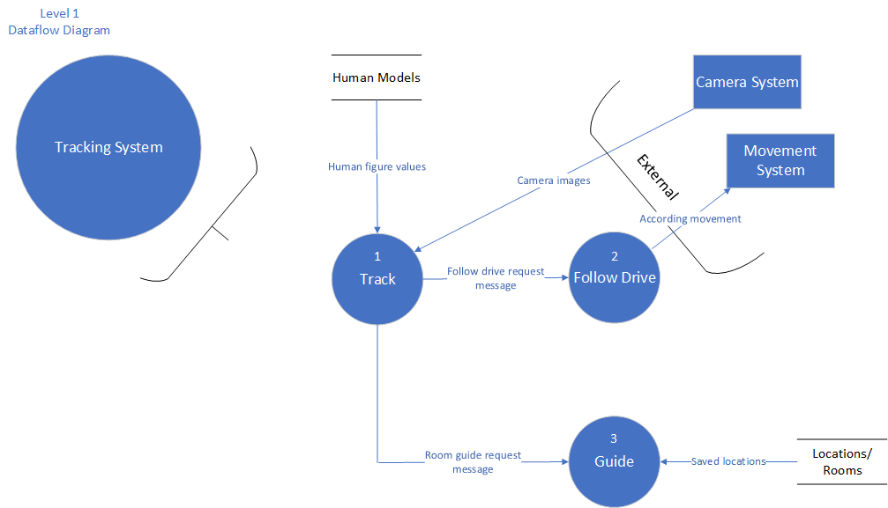

## 3.2 Sprint 4

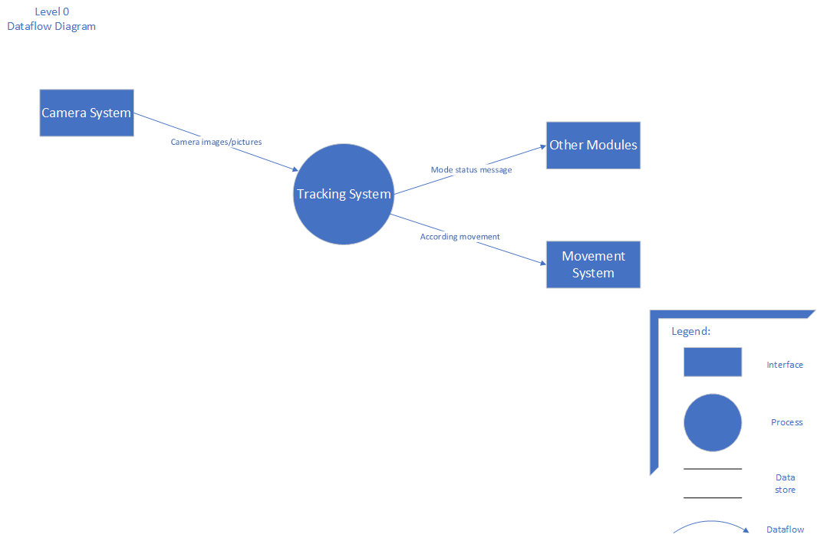

Figure 1 Level 0 DFD

Figure 2 Level 1 DFD

# Chapter 4: Input

Chapter consists of the input being added to the system by the external entities. Has the name that matches the diagram’s and information on its conditions.

|  |  |
| --- | --- |
| **Code input** | **Input CAMERA_IMAGES** |
| **Name** | Human tracking service |
| **Users** | Guest |
| **Objective** | Follow the guest around the location |
| **Frequency** | Per request |
| **Files** | Saved human face, figure and distinctive elements. PNG dataset files |
| **Screens used** | Main Screen/UI |

|  |  |
| --- | --- |
| **Code input** | **Input TRACKING_ID** |
| **Name** | ID of the tracked person |
| **Users** | Robot || N/A |
| **Objective** | Give the scanned person an ID for the system to process it for tracking purpose |
| **Frequency** | On request |
| **Files** | Integer variable |
| **Screens used** | None |

# Chapter 5: Output

Chapter consists of the output leaving the system. Has the name that matches the diagram’s and information on its conditions.

|  |  |
| --- | --- |
| **Code output** | **MOVEMENT** |
| Name | Send Movement commands |
| User | System |
| Objective | Send commands to move the robot in a certain direction |
| Frequency | Constant/When tracking active |
| Data to be printed | Movement Controls commands |

|  |  |
| --- | --- |
| **Code output** | **STATUS** |
| Name | Send status log message |
| User | System |
| Objective | Send .log messages across the system to inform about the current mode choice/status |
| Frequency | Constant/When tracking active |
| Data to be printed | .log/String data |

# Chapter 6: Menu Structure and Authorization

The table below shows the menu structure and authorization that any given user or administrator may have.

|  |  |  |  |
| --- | --- | --- | --- |
| **Menu Structure** | **Authorization** | | |
|  | User | Staff / Robot Operator | Administrator |
| Track Human | - | RW | RWUD |
| Settings (Mapping and other calibration settings) | R | RW | RWUD |
| Jurisdiction (Authorizing a receptionist/employee to access the robot) | - | R | RWUD |

**Legend:**

* R – Read
* W – Write
* U – Update
* D – Delete

# Chapter 7: Resources

Ultralytics. (n.d.). *Home*. Ultralytics YOLOv8 Docs. <https://docs.ultralytics.com/>

*Documentation - ROS Wiki*. (n.d.). <http://wiki.ros.org/Documentation>

*Gazebo Community*. (n.d.). Gazebo Community. <https://community.gazebosim.org/>